Homework Set #1

Due: Sept 18

- (10 points) Comparing Functions: What is the smallest integer value of n > 1 such that an algorithm whose running time is 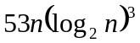 runs slower than an algorithm whose running time is 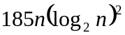 on the same machine? Justify your answer.

- (10 points) Exercise 1.2-2 (page 13).

- (10 points) Using Figure 2.2 on p. 17 as a model, illustrate the operation of INSERTION-SORT on the array A = < 798, 4, 123, 549, 12 >.

- (10 points) Using Figure 2.4 on p. 33 as a model, illustrate the operation of MERGE-SORT on the array A = < 798, 4, 123, 549, 12 >.

- (20 points) Exercise 2.3-4 (page 37).

- (20 points) Use a recursion tree to find a closed form solution to the following recurrence:
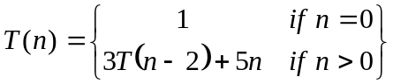
Assume that 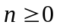 is an even integer.

